FOREST- WIDE OUTREACH
NORTHERN REGION
LOLO NATIONAL FOREST

fs.usda.gov/lolo

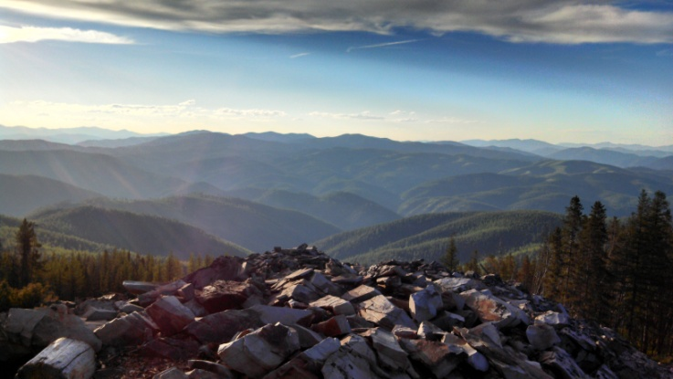
Multiple Temporary Seasonal Fire Positions
available at the following locations:
Lolo Supervisor’s Office, Helitack (Missoula, MT)
Missoula Interagency Dispatch Center (Missoula, MT)
Missoula RD and the Lolo Interagency Hotshot Crew (Missoula, MT)
Ninemile RD (Huson, MT)
Plains/Thompson Falls RD (Plains, MT)
Seeley Lake RD (Seeley Lake, MT)

Superior RD (Superior, MT)
Outreach Announcement for Temporary Fire Positions

Introduction
The Lolo National Forest will soon begin filling seasonal fire positions for the 2021 Fire Season. Openings are available at the GS-3, GS-4, and GS-5 levels. These are TEMPORARY SEASONAL positions with a maximum six month tour (NTE 1039 hours). Anticipated start date is mid-April to early-June, 2021.

If you have interest in temporary positions, or questions pertaining to a specific District, contact:
Jacob Fallis (Missoula District) 406-329-3851
Stryker Clark (Missoula District) 406-329-3942
Josh Stroot (Superior District) *** 406-822-3952
Bobby Henderson (Superior District) *** 406-210-1428
Cy Hanson (Seeley Lake District) *** 406-677-3929
Ryan Winebark (Seeley Lake District) *** 406-677-3918
Theo Johnson (Ninemile District) 406-626-5437
Matt Heisler (Ninemile District) 406-626-5417
Trevor Unsworth (Plains/Thompson Falls District) *** 406-826-4325
Tate Cavill (Plains/Thompson Falls District) *** 406-826-4336
Evan Day (Missoula Helitack) 406-829-7360
Josh Klare (Missoula Helitack) 406-329-4797
Shawn Faiella (Lolo Hotshots) 406-829-7000
Teresa Sage (Missoula Dispatch) 406-829-7052
*** Government Housing Available

Position | Grade | Vacancy Number
Entry-level Firefighter: The purpose of the position is to assist in performing the technical tasks of wildland fire program. Work is directly related to wildland fire suppression and control activities | GS-0462-02 | Will be issued September, 2020
Entry-level Firefighter: This position is for wildland fire suppression/management/control, as a firefighter on an engine, hotshot, helitack or hand crew. Other wildland fire related duties might involve fire prevention, patrol, detection, or prescribed burning. | GS-0462-03 | Will be issued September, 2020
Returning Firefighter: This position is for wildland fire suppression/management/control, as a firefighter on an engine, hotshot, helitack or hand crew. Other wildland fire related duties might involve fire prevention, patrol, detection, or prescribed burning. | GS-0462-04 | Will be issued September, 2020
Returning Firefighter: This position is for wildland fire suppression/management/control, as a firefighter on an engine, hotshot, helitack or hand crew. This position is categorized as a Senior Fire Fighter (SFF) position. Other wildland fire related duties might involve fire prevention, patrol, detection, or prescribed burning. | GS-0462-05 | Will be issued September, 2020
Hotshot/Handcrew: This position is located on a wildland fire crew. The purpose of the position is wildland fire suppression/management/control as a specialized firefighter. This position is categorized as a Senior Fire Fighter (SFF) position. Other wildland fire related duties might involve fire prevention, patrol, detection, or prescribed burning. | GS-0462-05 | Will be issued September, 2020
Helitack Crewmember: This position is categorized as a Helitack Senior Fire Fighter (SFF) position. Independently performs recurring fire suppression duties on a helitack crew as a senior firefighter. | GS-0462-05 (Helitack) | Will be issued September, 2020
Forestry Technician (Fuels): The position serves as a skilled member of a fuels management crew. Works independently or as a skilled member of a fuels management crew engaged in fuels management, including broadcast burning, hand and machine piling, helitorch, and other brush disposal techniques. | GS-0462-04  (Fuels) | Will be issued September, 2020
Forestry Technician (Fuels): The position serves as a skilled member of a fuels management crew. Collects and compiles resource data for long and medium range planning, treatment, and reporting of natural and created fuel hazard management program. Executes fuel treatment plans, slash hazard appraisals, and hazard reduction plans for slash creating projects or contracts. | GS-0462-05 (Fuels) | Will be issued September, 2020
Fire Dispatcher: This position serves as a Fire Dispatcher located in a dispatch center. This may be a single agency dispatch office or interagency dispatch center located in a fire management organization. | GS-0462-04  (Fire Dispatch) | Will be issued September, 2020
Fire Dispatcher: This position serves as a Fire Dispatcher located in a dispatch center. This may be a single agency dispatch office or interagency dispatch center located in a fire management organization. | GS-0462-05 | Will be issued September, 2020
Fire Lookout: This position is established on a Forest Service unit to provide for the detection and reporting of fires from a lookout station. | GS-0462-04 (Lookout) | Will be issued September, 2020
Fire Lookout: This position is established on a Ranger District and serves as a Lookout coordinating information between two Interagency Dispatch Centers and oversees two communities. The purpose of the position is to provide fire detection services to district fire suppression personnel. | GS-0462-05 (Lookout) | Will be issued September, 2020

How to Apply
Applicants must apply online at www.usajobs.com. You will be required to create a USAJOBS account and either create a resume or upload your own.

PLEASE NOTE: Announcements will be open from October 1, 2020 – October 11, 2020. Be sure to indicate the duty stations at which you are interested in working.

Please contact the individuals listed above for additional information.

